**TECHNICAL REPORT**



INITIAL SOFTWARE REQUIREMENTS SPECIFICATION OF A SOFTWARE PROJECT

**Version 1.0**

Pablo Almarza Marques

Miguel Arnáiz Montes

S. Xiao Fernández Marín

Samai García González

Carlos García Toledano

Group 5

02/03/2021



**CHANGE LOG TABLE**

|  |  |  |  |
| --- | --- | --- | --- |
| VERSION | DATE | CONTENT | PURPOSE |
| 0.1 | 24/02/2021 | Initial version of the presentation, draft. | Have all the points to be explained as schemes |
| 0.5 | 06/03/2021 | Introduction and some appendices done | End functionalities and requirements. |
| 0.7 | 08/03/2021 | Functionalities and requirements done. | Paste the mock ups and write the conclusions |
| 1.0 | 10/03/2021 | Finished version | Prepared for delivery |

**SUMMARY**

The UAM asked us to create an open-source software project to improve the current way of creating teams and working in them in an online way to carry out the different assignments of the university. In this document we will explain how this software will work and the improvements we have implemented compared to other softwares with similar purpose. The two main requirements that this software need to cover are:

1. *Creation of teams for practical assignments by subject in a single place.*
2. *Call, carry out and follow-up of the working meetings of the team.*

The beneficiaries of this software will be the students who have an account in Moodle (the educational platform that the university uses), although the application will be independent from it. This software will let them organise themselves for carrying out the practical assignments. It facilitates the creation of the teams for the different subjects of the university and manages a schedule with the different meetings a student has. It also notifies the students if they have a meeting, and checks that all members of a team can attend the meeting. In addition, it includes meeting management, opening automatically the room five minutes before the meeting starts, and finishing it five minutes after if all members have left the room. Furthermore, it provides access to different resources such as notebooks and whiteboards, to make communication during meetings easier. Besides, it contains trace information, which means that it keeps track of the objectives and results of each meeting, and even compresses in a file the assignment documents to deliver when the program date arrives.

In conclusion, the purpose of this system is to support the development of practical assignments of all the subjects of all the degrees from EPS-UAM and promote the integration and participation of all students.

In this document, we will explain the main goals of the system, why it is so necessary, how the design has been carried out, and the enhances we propose for the system. We also included some mockup designs to have a visual idea of the system.

**TABLE OF CONTENTS**

1. INTRODUCTION 1

1.1 Needs of the target group 1

1.2 Document goals 1

1.3 Project scope 1

1.4 Procedure 1

1.5 Methodology and background 2

1.6 Logical structure of the document 2

2 PROJECT DEFINITION 3

2.1 Goals and Functionality 3

Project Goals and Scope 3

All in one 3

2.2 Functionality 3

User login and authentication 3

Interact between students 4

Deliveries and schedule 4

Notifications 4

2.3 Initial Catalog Requirements 4

2.3.1 Functional Requirements 4

Team Management Subsystem 4

Meeting Scheduling Subsystem 4

Delivery subsystem 5

User based subsystem 5

2.3.2 Non-Functional Requirements 5

3. System Interaction. Conceptual and Visual Design 6

4. Conclusions 14

References 15

Appendices 15

Appendix A. Meeting minutes 15

Appendix B. Competitive analysis 20

Appendix C. Brainstorming results 22

## 1. INTRODUCTION

This document contains the Software Requirements Specification (SRS) for the Management Software System for EPS-UAM Teams Management for Practical Assignments.

The project covers the initial specifications of our Software System that will manage the practical assignments done by the students of the EPS-UAM, with a dedicated application for them.

The problem posed is the need to develop open-source software which will be responsible for managing the practices of different subjects. As now most of the assignments of the EPS-UAM are carried out in an online way, it is necessary to create a system that facilitates students and teachers the work.

### 1.1 Needs of the target group

Currently, EPS-UAM students must use different applications for the same objective, therefore the idea would be to unify several of the tools used to carry out, deliver or correct practical activities of different subjects.

### 1.2 Document goals

The main goal of this document is to give a detailed vision of the initial requirements of the software as well as some mock ups to have a preview of the application. On one hand, this will serve as a first contact point with the client, who can come up with any change or suggestion. It will also serve as a reference for the developers to base their work on it.

### 1.3 Project scope

The main goal of the project is to have a unique application that unifies the functionalities of meetings and working environment, that is, being able to work in the same app where you can have a meeting so it is more practical to use when working in groups. The users of the app will be the students and the teaching staff, also they will be the beneficiaries of the software since it will facilitate some labors.

### 1.4 Procedure

To get to this preliminary design of the application, we have first red in detail the requirements the client wanted to implement on the system, and then we have carried out different methods, such as brainstorming, where we join our ideas together to improve the system, we also made research on the Internet about other similar systems to see their strengths and weakness and so improved our proposed functionality, and finally we have design mockups to make an idea of how the system will work.

### 1.5 Methodology and background

The methodology we used to create our app started by finding out what applications share the same objectives that the one that was in our mind, and once we got 3 of them that were, for us, the ones that offered the best benefits, we investigated about what deficiencies they had, so we could solve them in our application.

### 1.6 Logical structure of the document

The project will be explained through its goals, functionalities and requirements. Moreover, the project will be shown as a series of mock-ups to show the interface. Finally, there will be a conclusion will be a synthesis about the whole project and a reflection for future work.

## 2 PROJECT DEFINITION

In this section we are going to describe the goals and the functionality of our application. We are also going to enumerate the functional and non-functional requirements.

### 2.1 Goals and Functionality

In this section we will include a short explanation of the goals in mind for the creation of this application and the functionality implemented for this goals to be achieved

#### Project Goals and Scope

For this project, our goal is to create a practical application that creates an accessible work environment for teachers and students to exchange ideas, help each other, consult their questions and evaluate the students' work.

The main objective behind making this application accessible is to promote the teamwork and exchange of ideas between students. For this to be possible, there will exist options for students to share their work on real time, post questions on forums and create meetings and sub meetings to discuss different topics.

This application is aimed only to students and teachers of the UAM so an identification will be necessary.

Accessibility

The application will be accessible to all students and teachers from the EPS-UAM who have an account in Moodle and UAM mail.

### All in one

In order to facilitate the work for both teachers and students we want to create an app that is able of having the deliveries clearly, that means, that you don't have to search all over the page for them but all the deliveries are perfectly visible while also having the deadlines right in front of you so there is no need to search for them since all of them will be on the same calendar where the user can receive notifications about the deadlines.

### 2.2 Functionality

In this section we will introduce the main functionalities of the application Docufy.

### User login and authentication

Users will be able to log in if it belongs to EPS-UAM and has the UAM mail.

### Interact between students

With the implementation of forums, we seek that classmates help each other to build more connexions between them.

### Deliveries and schedule

One of our main objectives is to have a clear way to know where we have to upload the assignments while being aware of the time remaining to send the corresponding assignment to each subject.

### Notifications

In order to not be constantly on the app to see the deadlines, notifications will appear just when you configure to advise you.

### 2.3 Initial Catalog Requirements

The functional requirement concerns subsystem functionality whereas the non-functional requirements concerns the functionality of our application. In the following sections we are going to specificate the requirements and subsystems that are essential.

#### 2.3.1 Functional Requirements

In the following list we are going to specify all the functional requirements of the Docufy application.

##### Team Management Subsystem

FR1. By default, the group class will be created by the application using the information provided by the class group of moodle.

FR2. Only the professors that are the administrators of the group class, will be able to create new sub-teams.

FR3. There will be a group called “Help Group”. In this specific team, students of the same course will be able to post their questions for other students to answer them.

FR4. The “Help Group” will be sorted by different subgroups of specific subjects.

FR5. Once a team is made, it will not be possible to change it.

##### Meeting Scheduling Subsystem

FR6. Add notes on the calendar to track on the assignments.

FR7. Notify if the assignment reaches a deadline.

##### Delivery subsystem

FR8. Have the schedule updated.

FR9. Max size for the files to deliver is 100 MB.

FR10. Notify the sender and the receiver that a file is sent.

FR11. Notify the user one day before each delivery.

##### User based subsystem

FR12. Create forums to ask and answer questions.

FR13. Manage which subject should appear first depending on the interests of the user.

FR14. Let others control your screen with your consent during a meeting.

FR15. Open your microphone or camera on your own.

FR16. Possibility to share screen.

FR17. Create a timekeeper for a meeting.

#### 2.3.2 Non-Functional Requirements

FNR1. Have the header of the application through the external meeting.

FNR2. Add a sound to the notifications.

FNR3. Change the language of the application to Spanish or English.

FNR4. Introduce mail of the UAM before entering the app.

FNR5. Identify the user of the app, so there can be students or teachers.

FNR6. The subjects groups will be sorted by labels. The labels will be “Question”, if you have an unresolved question, “Resolved” if the question you had was resolved and “Advice” if some students have realized something important about the assignments or the theory classes.

FNR7. Be able to change the theme (change colour, position, etc.)

FNR8. Be able to change the size and mode of the screen (fullscreen, not full screen...)

## 3. System Interaction. Conceptual and Visual Design

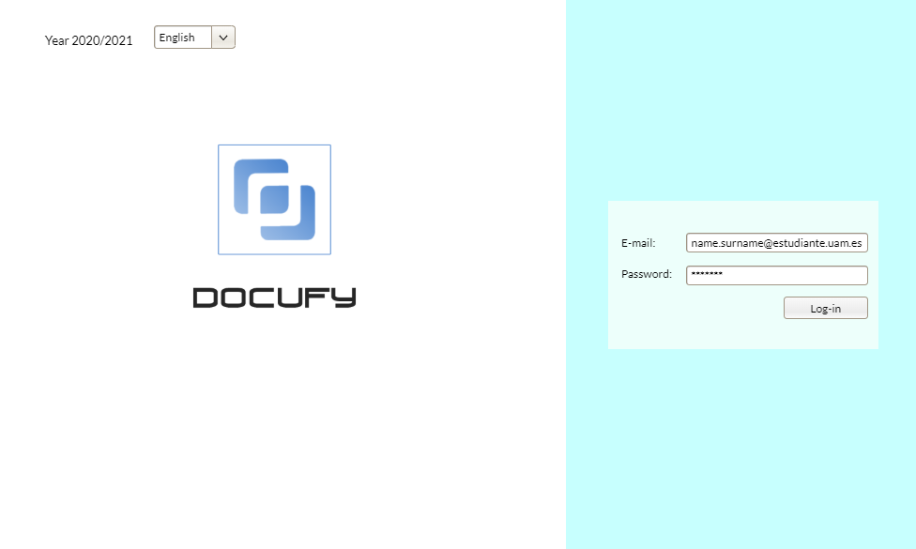

[Mockup 1]

This first mock-up shows us how our application would look when you first open it. At the right side is requested to enter an email and a password to login. It needs to be an educational email.

At the left upper corner the application will show the academic year and a combo box, for changing the language of the application in case the user does not understand english.

In the middle of the screen we can see the Docufy logo.

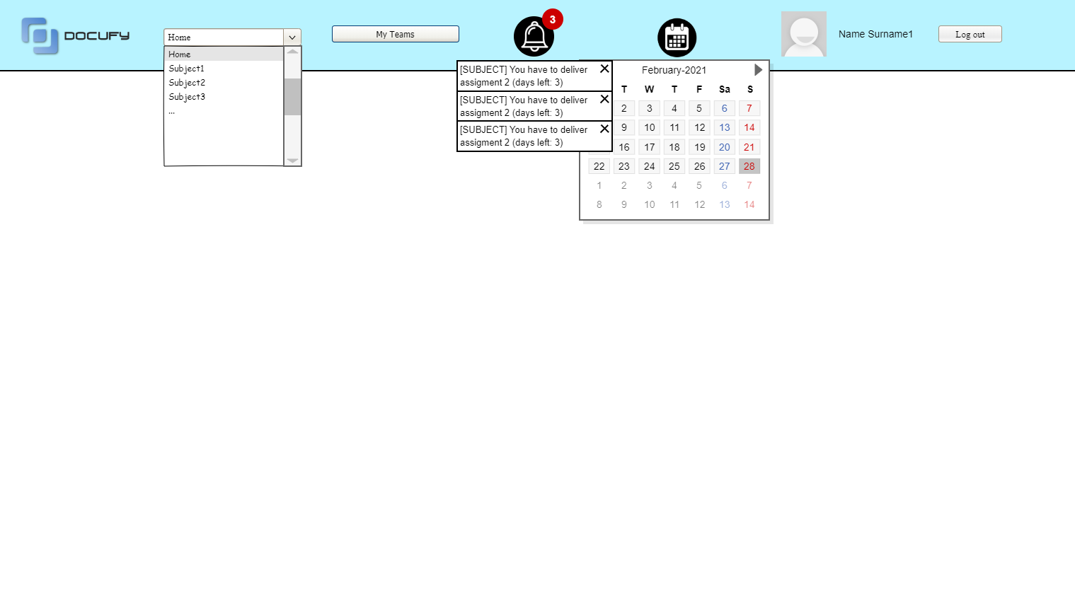

[Mockup 2]

When the student login, find a header that is common to all the screens that we will be able to navigate through.

It contains (from left to right) our logo, a combo box where the users can choose between all the subjects they have, a button to go to the teams the student has, a notification and a calendar drop-down menu.

If they press on one of the subjects they have in the combobox, the application will go to [Mockup 4].

If the student presses the “My Teams” button, the page will go to [Mockup 3].

The user can also see all the notifications of assignments he/she will have to submit and the programming meetings he/she has. The application will show the number of notifications the student has and if the user presses the icon, it will show the complete notification.

It happens something similar with the calendar icon, where if the user clicks on it, it will show a calendar with all the deadlines of different subjects (differentiated by colors).

Finally the student can find his/her name on the right corner as well as a logout button.

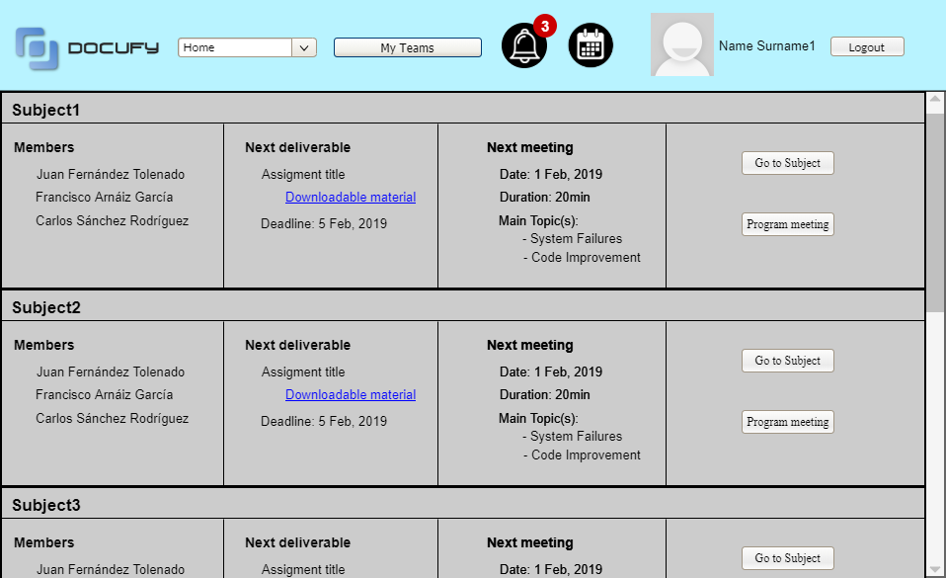

[Mockup 3]

In this page the users can see all the subjects they have. They can also see the assignments they have and the deadline of them. In addition users can also see the members they are in group with and all the planned meetings.

We can also see that we can add some download links if a project needs a base code or a template for a subject.

The application also let you program a new meeting on this page.

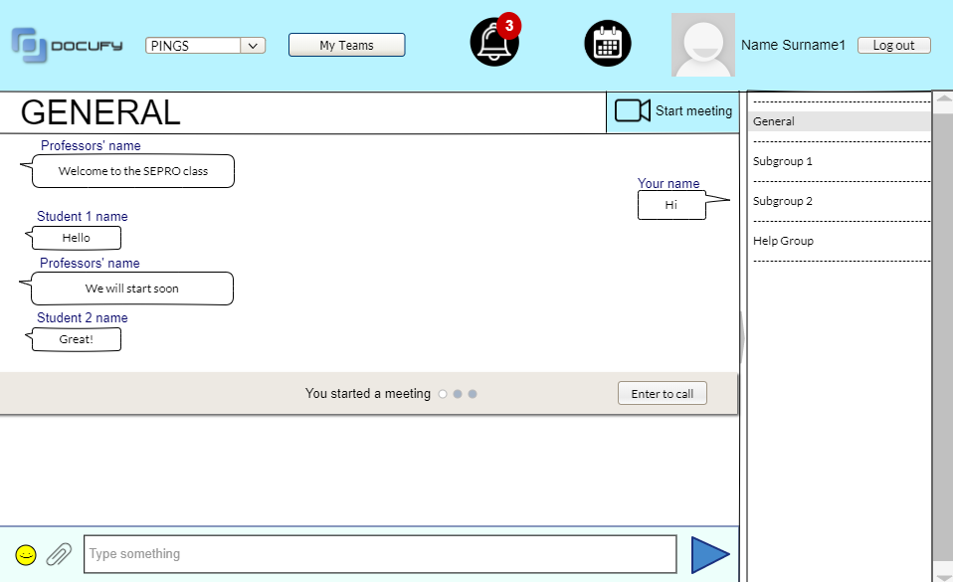

[Mockup 4]

In this page we can see how a general meeting would look like.

A general meeting has all the students of the subject as participants.

It allows the students to create a video-call (showed at the [Mockup 5]) and has a general chat.

At the right side of the screen the student can choose between all the subgroups he/she has of the subject ([Mockup 6]) and the “Help Group” ([Mockup 7]).

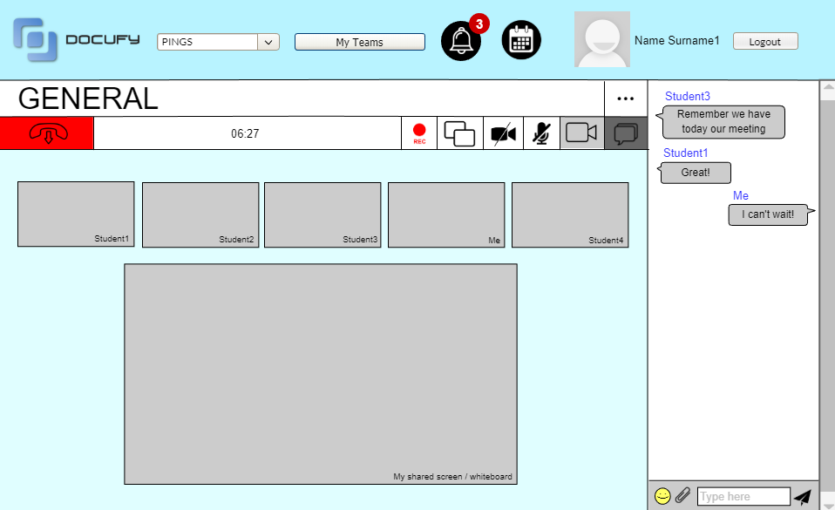

[Mockup 5]

This mock-up shows the video-call page, that is linked to an external association.

It has a chat at the right side of the screen in case a student does not have a microphone or there are some questions that the professor can not attend at a specific moment.

It also has the options of recording a meeting, letting others control your computer and turn on and off your own camera and microphone. At the top of the call we can see the time we have been on a call and the left icon is for hanging up the call.

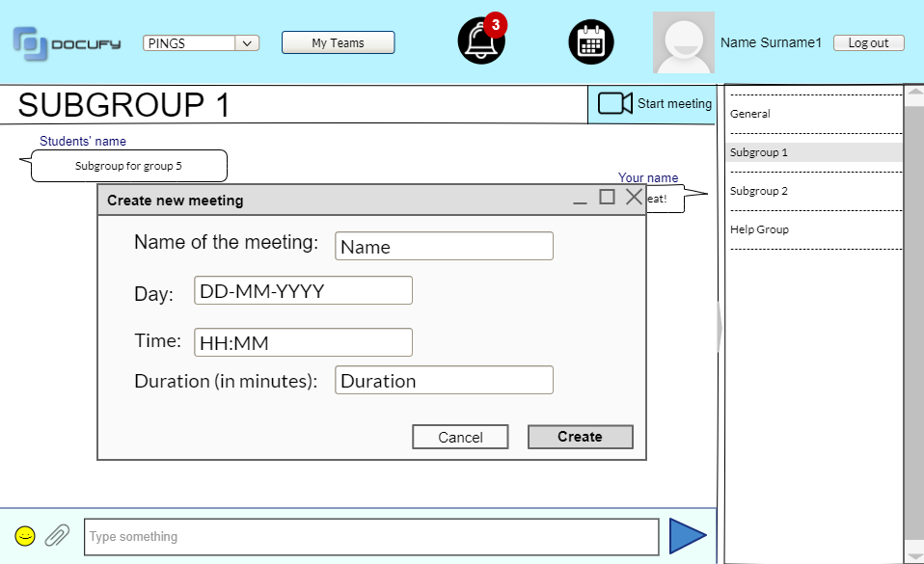

[Mockup 6]

In this mockup we see how the screen would look like when a student is in a subgroup with the teammates which he/she has to do an assignment with.

When pressing the “Start meeting” button at the right side, the application will pop up a new window in which the student can decide different features of the meeting.

These features are the name that the meeting will have, the day of the meeting and also the time. The student will also have to enter the estimated minutes of the meeting.

It also has a chat to communicate with the teammates when the student does not have another communication way as his/her phone number. In this way they can agree at what time and wich day the meeting would be better.

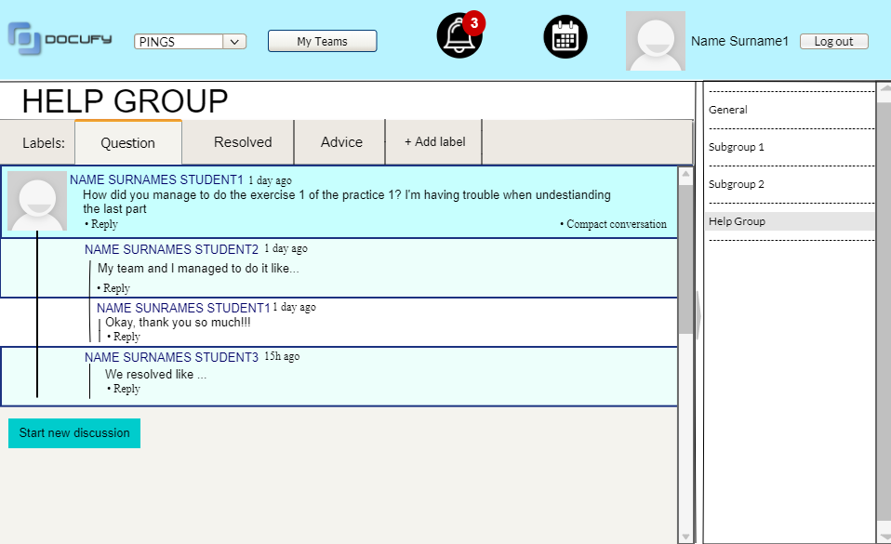

[Mockup 7]

This mockup shows the help group page in a specific subject. The students will have a tab to create new questions or see the ongoing ones. After a question has been solved it will move to the “resolved” tab.

Moreover, the application has a label called “Advice”, in case a student finds an error on the practice or the theory slides, can warn the other students through this label.

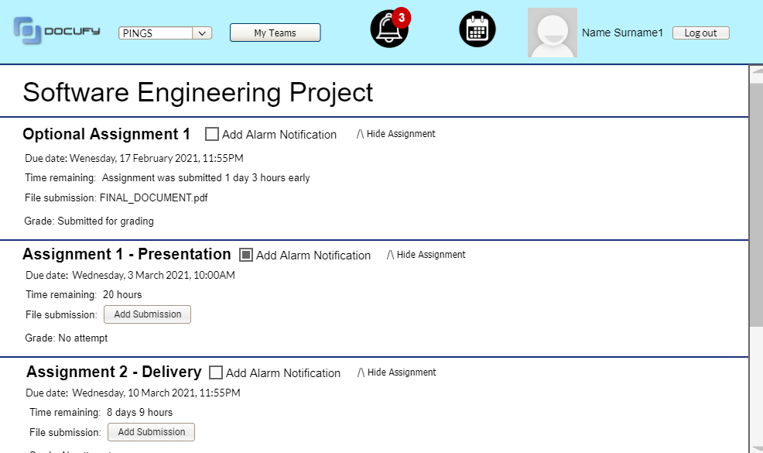

[Mockup 8]

This mockup represents the page in which the student will hand in their assignments of each specific subject. There are options in which the user can receive a notification when the deadline approaches or to hide the assignment if it is already handed in.

## 

## 

## 

## 

## 

## 

## 

## 4. Conclusions

**- Global summary related to the introduction:**

With Docufy, EPS students will have a compact tool where they will have an organized way of working in teams while providing and receiving help if needed. Until now, they had to use different applications, each one with a different purpose. But Docufy unifies all these necessities in one, so it will give them a lot of facilities for carrying out their assignments, so necessary in UAM degrees, as the main part of the subjects is practical. Also this system provides them a way to have knowledge of what they have to do and for when, as the system includes a very complete schedule with the meetings programmed and the pending activities they have.

**- Discussion of the proposed system:**

Although the system has a lot of advantages, it also has some drawbacks.

While the economic investment should not be too much, because we don´t need any kind of material except for software ones, the coding phase will be hard and take time, as we want to implement a lot of functionalities, some of them innovative and new.

**- Discussion of the contributions of the proposed system:**

In summary, we can say that the system gives dynamism to the work of the students and teachers, and in general it facilitates it.

It also contributes with an innovative way of working online, as it is something that has not been created at all.

**- Benefits to be obtained:**

This is an important point for both the client, in this case the UAM, and the software development company. On the one hand, as everything will be automatized and unified in a single system, teachers and students will benefit from this and save a lot of time. Also, as this is a very attractive and innovative application, this will catch people and bring in new students, as it could be something decisive when choosing where to study.

Finally, the benefit for the development company will be great, as they only need to pay for developers, but not for material.

**- Limitations of the proposal:**

Some of the limitations studied are that by the moment the application can only be used by users registered in Moodle, as it is linked to it, so external users can´t make use of it.

Another limitation is the language in which it is available. This is something we have not talk about with the client, but it is possible that in the beginning it would also be disposable in English and Spanish.

**- Future work:**

In the future, some improvements or additions could be incorporated, such as:

* System available in more languages.
* System available for everyone, not necessarily people with an account in the UAM.
* Other enhancements to be studied.

## References

We have based our ideas and designs in different sources, here we present them:

For creating the logo:

Adobe Photoshop

For the mockups:

[1] [https://app.pencilapp.net](https://app.pencilapp.net/#/login)

For competitive analysis:

[2] <https://www.zasche.com.mx/post/zoom-y-skype-ventajas-y-desventajas>

[3] <https://docs.microsoft.com/es-es/microsoftteams/limits-specifications-teams>

[4] <https://www.skype.com/es/features/>

## Appendices

### Appendix A. Meeting minutes

*1st Meeting minute:*

**MEETING ANNOUNCEMENT**

**From:** 13:00h

**To:** 14:00h

**DATE AND TIME:** February the 16th 13:00

**PLACE:** MS Teams

**DURATION:** 1h

**PURPOSE:** Understand the application that we were asked to do

1. **AGENDA**

-

1. **DECISION FOLLOW-UP**

-

1. **DOCUMENTATION**

-

-------------------------------------------------------------------------------------------------------------------------------

**MEETING MINUTE**

**DATE AND TIME:** February the 16th, 13:00h

**PARTICIPANTS:** Pablo Almarza, Miguel Arnaiz, Carlos García, Samai García and S. Xiao Fernández

1. **KEY POINTS DISCUSSED**

Brainstorming.

1. **DECISIONS MADE**

|  |  |  |
| --- | --- | --- |
| **ACTIONS** | **RESPONSIBLE PERSON** | **DEADLINE** |
| Brainstorming file | Pablo Almarza  Miguel Arnaiz  Carlos García  Samai García  S. Xiao Fernández | Due 17/02/2021 |

*2nd meeting minute:*

**MEETING ANNOUNCEMENT**

**From:** 11:00h

**To:** 13:00h

**DATE AND TIME:** February the 17th, 11:00h

**PLACE:** MS Teams

**DURATION:** 2h

**PURPOSE:** Specifying software system requirements

1. **AGENDA**

Bases for the application we are asked to do and how we could do it

1. **DECISION FOLLOW-UP**

How the application is going to be displayed to the users that are going to use it. And which features are going to be essential to program first.

1. **DOCUMENTATION**

Brainstorming pdf

-------------------------------------------------------------------------------------------------------------------------------

**MEETING MINUTE**

**DATE AND TIME:** February the 17th 11:00

**PARTICIPANTS:** Pablo Almarza, Miguel Arnaiz, Carlos García, Samai García and S. Xiao Fernández

1. **KEY POINTS DISCUSSED**

Competitive analysis, essential points that are necessary to let the application be usable and accessible to everyone.

1. **DECISIONS MADE**

|  |  |  |
| --- | --- | --- |
| **ACTIONS** | **RESPONSIBLE PERSON** | **DEADLINE** |
| Competitive analysis | Samai Garcia  S. Xiao Fernandez | Due 19/02/2021 |
| Statement analysis | Pablo Almarza  Carlos García | Due 20/02/2010 |
| Meeting minutes week 17/02/2021 | Miguel Arnaiz  S. Xiao Fernnadez  Carlos Garcia | Due 17/02/2021 |

*3rd meeting minute:*

**MEETING ANNOUNCEMENT**

**From:** 11:00h

**To:** 13:00h

**DATE AND TIME:** February the 24th, 11:00h

**PLACE:** MS Teams

**DURATION:** 2h

**PURPOSE:** Draft of Technical Report

1. **AGENDA**

-

1. **DECISION FOLLOW-UP**

The way we are going to sort the technical report and each part.

1. **DOCUMENTATION**

Brainstorming, competitive analysis, statement analysis

-------------------------------------------------------------------------------------------------------------------------------

**MEETING MINUTES**

**DATE AND TIME:** February the 24th 11:00h

**PARTICIPANTS:** Pablo Almarza, Miguel Arnaiz, Carlos García, Samai García and S. Xiao Fernández

1. **KEY POINTS DISCUSSED**

Distribute the different parts of the technical report and the oral presentation, prepare the mockups of our system,

1. **DECISIONS MADE**

|  |  |  |
| --- | --- | --- |
| **ACTIONS** | **RESPONSIBLE PERSON** | **DEADLINE** |
| Mockups | Miguel Arnaiz  S. Xiao Fernandez | Due 02/03/2021 |
| Prepare oral presentation | Pablo Almarza  Carlos García  Samai García | Due 09/03/2010 |
| Complete technical report | Pablo Almarza  Miguel Arnaiz  S. Xiao Fernnadez  Carlos Garcia  Samai García | Due 09/03/2021 |

*4th meeting minute:*

**MEETING ANNOUNCEMENT**

**From:** 13:00h

**To:** 14:00h

**DATE AND TIME:** March the 9th, 13:00h

**PLACE:** MS Teams

**DURATION:** 1h

**PURPOSE:** Finish technical report and complete reflective document

1. **AGENDA**

-

1. **DECISION FOLLOW-UP**

Complete technical report, do the appendices, prepare the reflective document and review everything before delivery.

1. **DOCUMENTATION**

Brainstorming, competitive analysis, statement analysis, meeting minutes, technical report draft.

-------------------------------------------------------------------------------------------------------------------------------

**MEETING MINUTES**

**DATE AND TIME:** March the 9th 13:00h

**PARTICIPANTS:** Pablo Almarza, Miguel Arnaiz, Carlos García, Samai García and S. Xiao Fernández

1. **KEY POINTS DISCUSSED**

Distribute the different parts of the technical report and the oral presentation, prepare the mockups of our system,

1. **DECISIONS MADE**

|  |  |  |
| --- | --- | --- |
| **ACTIONS** | **RESPONSIBLE PERSON** | **DEADLINE** |
| Write the reflective document | Pablo Almarza  Carlos García  Samai García | Due 10/03/2010 |
| Complete technical report | Pablo Almarza  Miguel Arnaiz  S. Xiao Fernnadez  Carlos Garcia  Samai García | Due 10/03/2021 |

*5th and last meeting minute:*

**MEETING ANNOUNCEMENT**

**From:** 13:00h

**To:** 14:00h

**DATE AND TIME:** March the 10th, 13:00h

**PLACE:** MS Teams

**DURATION:** 1h

**PURPOSE:** Review everything before delivery

1. **AGENDA**

-

1. **DECISION FOLLOW-UP**

Review technical report and reflective document

1. **DOCUMENTATION**

Brainstorming, competitive analysis, statement analysis, meeting minutes, technical report, reflective document.

-------------------------------------------------------------------------------------------------------------------------------

**MEETING MINUTES**

**DATE AND TIME:** March the 10th 13:00h

**PARTICIPANTS:** Pablo Almarza, Miguel Arnaiz, Carlos García, Samai García and S. Xiao Fernández

1. **KEY POINTS DISCUSSED**

Is the technical report complete? Read again the complete assignment to make sure we have done everything.

1. **DECISIONS MADE**

|  |  |  |
| --- | --- | --- |
| **ACTIONS** | **RESPONSIBLE PERSON** | **DEADLINE** |
| Review everything | Pablo Almarza  Miguel Arnaiz  S. Xiao Fernnadez  Carlos Garcia  Samai García | Due 10/03/2021 |

### Appendix B. Competitive analysis

Research of other applications with similar purpose as the one we are going to create, to identify the positive and negative aspects, so that it is useful for adding functionality and improvements to our system. In this study, we have analysed three different programs: *Teams*, *Skype* and *Zoom*. We show the result of this study in *Table 1*.

|  |  |  |  |
| --- | --- | --- | --- |
| **System** | **Positive Aspects** | **Negative Aspects** | **Ideas for our Project** |
| Docufy | * Allows students to meet with their classmates and work together. * Allow to get help from other students through a forum. * Accessible from Moodle page. * Contains a schedule for meetings integrated in the Moodle calendar.. * At the end of each meeting, there is a meeting minute. | * Only users from Moodle can access the program. * Once you enter a team, no member is able to leave it. * Need of an external application to have talk between members   .   * Can’t create teams through the app. | * Teams and channels creation * No limit in the number of participants in a meeting * You can choose the time duration of your meetings. * Possibility to access through the internet, no need to download the app. |
| *Teams* | * Allows to have a repository of shared documents. * Created with educational purpose. * You can create up to 250 different teams. * Private chats. * Allows to edit simultaneously shared documents through the app. | * Can only be used by registered users * Can only visualize a limited number of participants in the main screen |  |
| *Skype* | * Good quality audio and video calls. * Allows to record the calls * Calls to phone numbers * No time restriction | * For phone calls you need to pay. * Max. number of participants is 50 |  |
| *Zoom* | * Free version allows to connect until 100 participants * Easy to use * Can visualize many participants in the screen | * For meetings of more than 40 minutes you have to pay. * You need to download the app to use it, there is no online access. |  |

[Table 1]

### 

### Appendix C. Brainstorming results

At the beginning of the project we brainstormed in order to have some ideas about the system, and we later put these ideas in order and prioritize them. The ones highlighted are the ones we determined as more relevant. We can observe the result in *Table 2*.

|  |  |  |
| --- | --- | --- |
| **First ideas** | **Second ideas** | **Third ideas** |
| Feature to share screen and to let others control your laptop/pc because sometimes some apps do not let you share online code, uml, etc so it will come great. | Allow it to be connected to google calendar or other apps to know when you should deliver the assignment as it is better to have it all in one place. | Be able to download the time each member has been working or has been in the call or has changed a thing |
| If you are in a meeting, the system automatically sets you as occupied/in a call | Possibility to visualize everyone who is connected to the meeting and not just the number of participants | Can connect directly from moodle app |
| Create a forum to discuss about each part of the practice while making an incentive to participate in the forum | Open code for every group to compare things made and help others with an idea that no-one realized | Enable the creation of teams that are not in the same group to help each other in the development of their project |
| dentro de la pestaña del grupo que haya un calendario con las fechas de entrega específicas de ese grupo | Have an internal app to write code live with the team members | Noise filtering in calls |
| During a meeting, you can create a subgroup to comment ideas with your classmates. | Within each course there will be a section for theory, exercises and practical assignments. Having an option to create meetings in those sections. | Being able to connect directly to google docs or similar service. |

|  |  |  |
| --- | --- | --- |
| Be able to send notifications to the people to notify them | Be able to connect it to a mobile app and edit there the code, word or other things | Be able to leave comments (but not in the code but like in a side of the document) in the file |
| Each student can access to the schedule of its classmates of the team, so it is easier to program a meeting | Add a timekeeper in the screen while the meeting is carried out | The camera and microphone can only be activated by each self |
| Enable a team timer to let the professor that there is a need to solve something so he/she doesn’t forget it | Have shortcuts to specific things such as a PDF or a meeting. | Finish automatically a meeting after some minutes when an hour has been reached |
| Connect to a shared google calendars for the group | Being able to show the teacher a highlighted part of some document to resolve a problem | Being able to give control of your pc to your meeting members |
| Having private chats in each meetings to include people who have mic and mute people. | Being able to comment others code, this can be to point out an error or a curious way of doing something. | An option to make visible your meeting and letting others going in and watch you work. |

[Table 2]